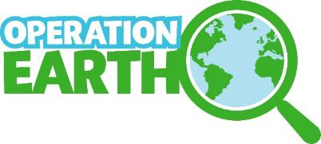

Operation Earth Phase 2

The Vision: To inspire curiosity in a wide-range of families with school-age children to enjoy, contribute to, question and critically think about environmental science research and its processes, making the link between the environment and their everyday lives and interests, with a special focus on reaching people who would not have engaged with this programme before.
The Mission: To deliver an inspirational and exciting national hands-on environmental science programme that reaches widely, in partnership with seven selected UK Science and Discovery Centres and Museums, sparking conversations about science, sharing the latest evidence and ways to get involved, training Science Centre staff and researchers, and inspiring curiosity and critical thinking.

